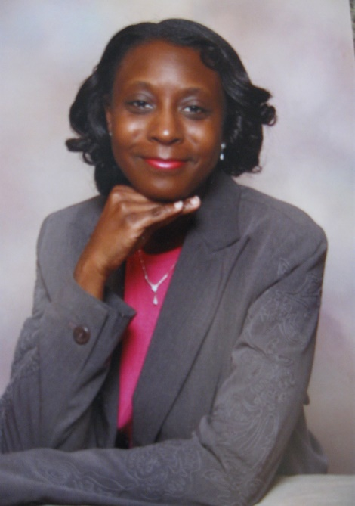
The Rev. Kotosha Griffin was born in Danville, Virginia, and grew up in Richmond, Virginia. She is the eldest of two children. She is a graduate of Barber-Scotia College with a BA in Political Science/Pre-Law. Upon hearing the call of God on her life, she decided not to pursue law school. Instead, Rev. Griffin moved to Washington, DC and attended Wesley Theological Seminary and earned a Master of Divinity. On June 17, 2017 Rev. Griffin was ordained an elder in full connection in the United Methodist Church. She loves to play tennis in her spear time. Rev. Griffin is married to Rev. Bertrand Griffin II.
Rev. Griffin was a GBHEM (General Board of Higher Education and Ministry) mentee in the Journey Toward Ordained Ministry Scholarship (JTOM). She later became a mentor to help mentees navigate through the process of ordained ministry. This mentoring also helped candidates to decide whether to become an ordained deacon or elder. As a mentor, Rev. Griffin motivated people to become better ministers through this process, but also helped them with life’s challenges.
Rev. Griffin has served multiple churches in the United Methodist Church, where she has been dedicated to preaching the word of God to help transform lives for Jesus. She also brings her knowledge of strategic planning, helping churches with their short- and long-term goals.
Through the leadership of Bishop Sharma D. Lewis, Rev. Griffin is enhancing her leadership capacity by participating in a cohort for multi-ethnic congregations by Mosaix. This cohort helps leaders to establish healthy multi-ethnic and economically diverse, culturally intelligent, socially just, and financially sustainable churches to express God’s love to all people. This cohort brings a wealth of knowledge and training.
Rev. Griffin is also currently pursuing a certificate at Vanderbilt University’s School of Business Management. Concurrently, she is pursuing a Doctorate in Multi-ethnic congregations at United Theological Seminary.
Under Rev. Griffin’s leadership, churches have grown in worship attendance. They have also grown spiritually and financially because of the preached word of God and showing grace to others that Christ can transform lives in the community and the world.
Rev Griffin is a leader who believes in equipping the saints in helping others to find their gifts and talents and use them to build the ministries of the church. The scripture that she lives by is 1 Corinthians 2:1-2 “When I came to you, I came not with excellency of speech or of wisdom, declaring unto you the testimony of God. For I determined not to know anything among you, save Jesus Christ and Him crucified.”

